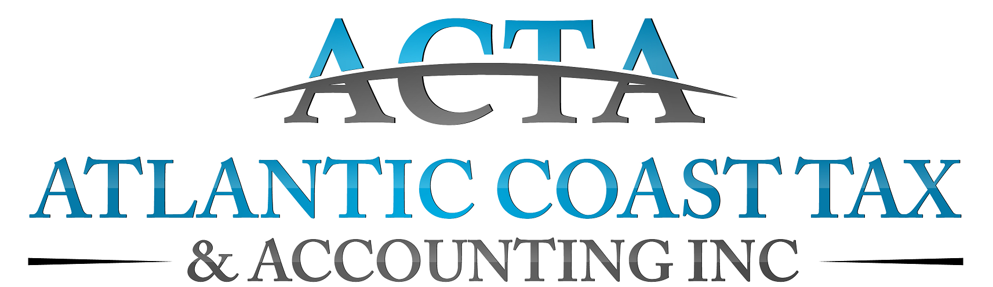

=
856 Lowcountry Blvd., Suite 100, Mount Pleasant, SC 29464
843.593.9311 • 843.277.6591

Dear Client(s):

Thank you for choosing Atlantic Coast Tax & Accounting, Inc. (ACTA) to assist you with your income taxes.

Please complete our client questionnaire and return same to us, along with the information/documents requested therein and records of any and all income (including, but not limited to, W-2s, K-1s, 1099s, unemployment and Social Security income, etc.). For your convenience, we offer our clients a secure online portal where documents can be uploaded, or you may schedule an appointment to come into the office. An appointment can be made online by visiting www.atlanticcoasttax.com or by calling our office at 843-593-9311.

Finally, please be advised that ACTA must have all necessary forms and documents to begin preparing your returns.

Engagement/retention agreement: This letter confirms the terms of our engagement with you and outlines the nature and extent of the services we will provide. Any difference in your understanding of said terms must be submitted to ACTA in writing prior to the exchange of any further information/documentation.

In accordance with our agreement, and upon receipt of all fully executed and completed forms, together with all requested information/documentation, we will prepare your federal and/or state income tax returns. We will depend on you to provide the information we need to prepare complete and accurate returns. We may ask you to clarify some items but will not audit or otherwise verify the data you submit. An organizer is available upon request to help you collect the data required for your return. The organizer will help you avoid overlooking important information. By using it, you will contribute to efficient preparation of your returns and help minimize the cost of our services. Our mutually agreed upon fee will be determined based upon the anticipated time spent on and the complexity of the return(s). Invoices are due and payable upon presentation.

Any additional bookkeeping performed in order to prepare your tax returns will be charged. Please be advised that after February 1st, standard rate for prime tax season is $250 per hour, with a two hour minimum. Our engagement should not be relied upon to disclose errors, fraud, or other illegal acts, though it may be necessary for you to clarify some of the information you submit. We will, of course, inform you of any material errors, fraud, or other illegal acts we discover. The law imposes penalties when taxpayers underestimate their tax liability. Please call us if you have concerns about such penalties.

Should we encounter instances of unclear tax law, or of potential conflicts in the interpretation of the law, we will outline the reasonable courses of action and the risks and consequences of each. We will ultimately adopt, on your behalf, the alternative you select.

We will return your original records to you at the end of this engagement. In the event you are unable to pick up your documents, or request any documents be returned to you or any documents and/or payments be forwarded to third parties, please be aware that said documents and/or payments will be transmitted via certified mail and charged to your account. You should securely store these records, along with all supporting documents, canceled checks, etc., as these items may later be needed to prove accuracy and completeness of a return. We will retain copies of our records and work papers for seven years, after which these documents will be destroyed.

Our engagement to prepare your tax returns will conclude with the delivery of the completed returns to you (if paper filing) for your signing, and the subsequent submittal, of your tax return (if e-filing). If you have not selected to e-file your returns with our office, you will be solely responsible to file the returns with the appropriate taxing authorities. Review all tax-return documents carefully before signing them. Please be advised that the IRS may experience delays in processing returns once they are filed and we are not responsible for IRS delays in processing your returns, issuing a refund or applying a refund to other tax amounts you owe.

In the event you, the client(s), require an extension of time beyond the filing deadline be prepared and submitted, and it is anticipated that you, the taxpayer(s) will owe money, it is your responsibility to make payment of anticipated taxes prior to the tax deadline in order to avoid penalties being assessed. Should you request Atlantic Coast Tax & Accounting make any such payment(s) on your behalf at the time of the filing of said extension(s), it is your responsibility to provide Atlantic Coast Tax & Accounting with verbal and/or written authorization as well as payment information details.

Waiver and Release of Liability: You (“the client(s)”) agree to indemnify, defend, and hold Atlantic Coast Tax & Accounting harmless from any claims and/or liability, fines, penalties and/or fees arising from the importation or exportation of client information and/or documentation, including, but not limited to the inaccuracy of entry, unsecured transmittal of data and/or documentation supplied by client(s) or its agent or representative, etc.; and further agrees to indemnify and hold Atlantic Coast Tax & Accounting harmless against any and all liability, loss, damages, costs, claims, penalties, fines and/or expenses, including, but not limited to penalty fees, etc., which the client(s) may hereafter incur, suffer or be required to pay.

We appreciate your confidence in us. Please call if you have questions.
Sincerely,

Clint Hulsey, President
REQUIRED: Please initial one of the following:

_____ I/we wish to add audit protection when my/our returns are filed for an additional charge of $60. I/we understand that this is the cost to opt in for audit protection and does not benefit my/our tax preparer. I/we also understand that this will entitle me/us to assistance with any tax notice, audit, or identity theft issue I/we may encounter. I/we understand that these services will be provided by Tax Protection Plus, which is not affiliated with Atlantic Coast Tax & Accounting, its owners, representatives, employees, successors and/or assigns.

_____ I/we opt out of the option to add audit protection when my/our returns are filed. I/we acknowledge that the IRS has significantly expanded hiring efforts which may increase the likelihood of an audit. I/we understand that, in the event I/we encounter any tax, audit or identity theft issues, for which we request the assistance, guidance and/or engagement of services of Atlantic Coast Tax & Accounting, I/we will be billed at the standard hourly rate. Please be advised that the standard rate for prime tax season (between February 1st and June ) will be charged at no less than $250 per hour, with a two hour minimum.

Accepted By:

________________________________ ________________________
Taxpayer Date

________________________________ ________________________
Spouse Date

(*Both spouses must sign for preparation of joint returns*)

